Extra Example 1

Consider the following precedence table for DRK Design Project

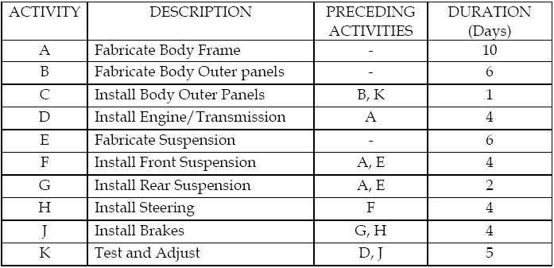

- Using the data given above, draw the PERT chart.
- Write down all the independent paths within the project.
- What is the duration of the project?
- What is the slack time for Activity G?
Extra Example 2

Consider the following precedence table for gathering information phase:

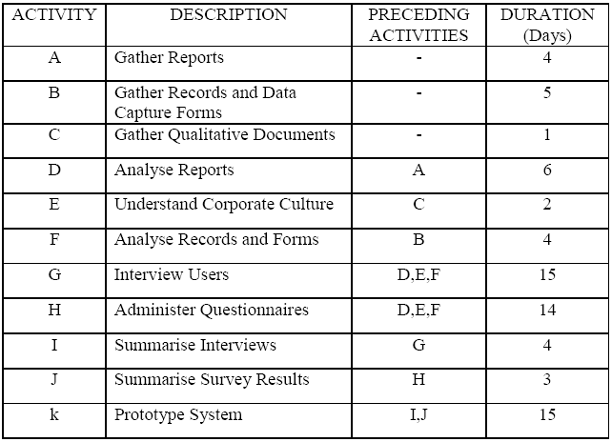

- Using the data given above, draw the PERT chart.
- Calculate and determine the critical path.

